Risk Register
This section identifies and assesses risks that could affect our projects success. Our full risk register categorizes each risk by its potential impact, outlines mitigation strategies, and assigns responsibility in addition to management actions. For data sensitive systems like ours, maintaining a clear systematic risk register is essential in supporting proactive decision making through documentation, assessment for severity and frequency of risks to successfully mitigate the consequence of setbacks.
To determine the overall priority of each risk category (legal, project management, operational and technical) our final rating was calculated using the weighted formula:
$$Rating = [Σ(wᵢ·nfᵢ) / Nf] × [Σ(wᵢ·nsᵢ) / Ns]$$
The formula combines the weighted frequency average and the weighted severity average to produce a balanced measure of overall risk exposure per category. Using this method, Project Management emerged as the most critical category with the final rating of 11.69. Despite its moderate frequency score, the consistently high severity scores indicate that teamwork related risks have significant consequences. Technical risks ranked second (10.88) with a blend of moderate frequency and severity scores. Although infrequent, Legal risks ranked third (10.00) due to the critical severity of risk while Operational ranked lowest (8.75), with both lower frequency and severity in comparison to other categories. These results indicate our need to prioritise project management and technical components of our project moving forward, with concentration on our mitigation techniques, while legal risks require targeted control due to their high potential impact.
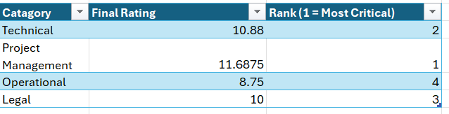

Appendix A: Risk Register

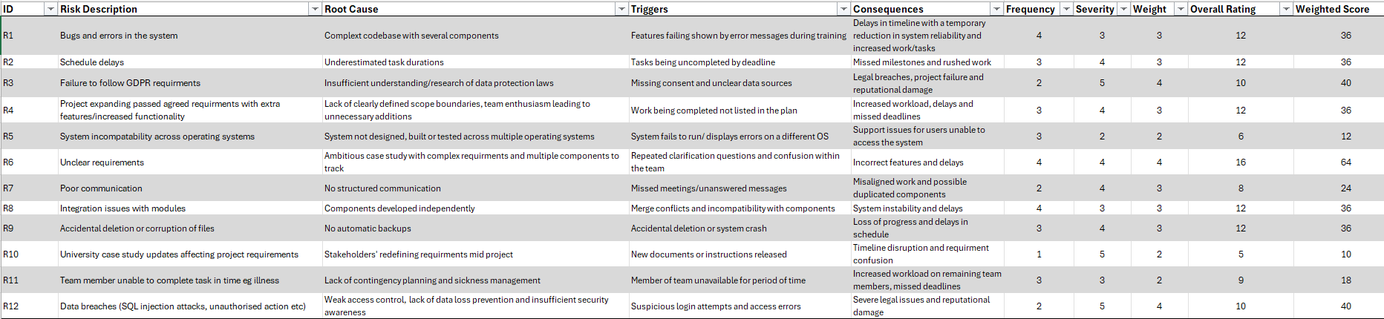
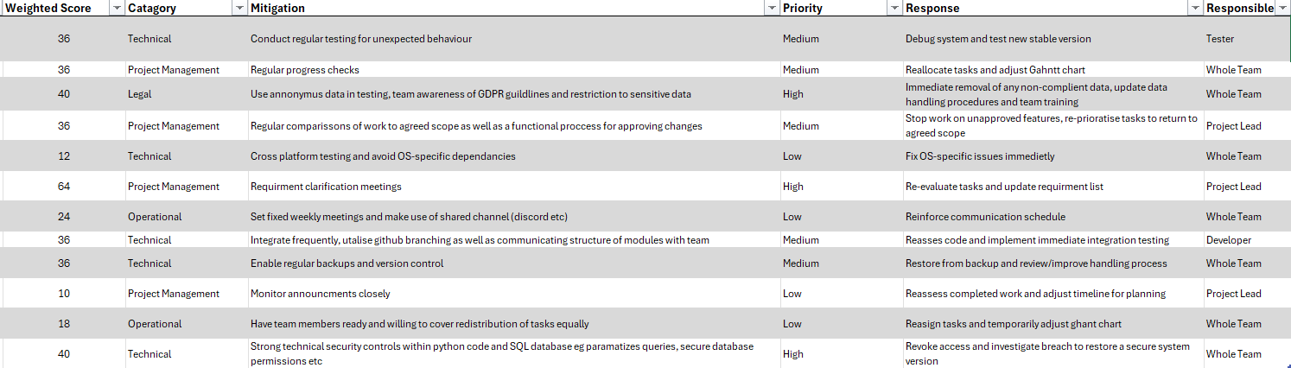
A1. Sheet 1 Full Risk Register (available on excel doc)

A2. Sheet 2 Scoring System
- Frequency Definitions:
- F1 - Rare
Risk is unlikely to occur but may happen in exceptional circumstances
- F2 – Unlikely
Risk could occur, but is unexpected during normal operations
- F3 – Possible
Risk may occur occasionally; there is a reasonable probability of it happening
- F4 – Likely
Risk is expected to occur regularly and possibly repeatedly
- F5 – Very Likely
Risk is expected to occur frequently and is predictable
- Severity Definitions:
  - S1 – Insignificant
Risks impact is minimal with no disruption to operations
  - S2 – Minor
Risk impact is small with limited disruption that is easily managed
  - S3 – Moderate
Risks impact is noticeable and requires intervention and perhaps operational delays
  - S4 – Major
Risks impact is significant and disrupts operational tasks, delivery and possibly data integrity
  - S5 – Critical
Risk causes severe impact on possible system structure or data integrity, leading to system failure or legal consequences

Appendix B: Supporting Calculations
B1. Overall rating (Sheet 1; Column I)
$$Overall Rating=\left(Frequency∙Severity\right)∙Weighted Importance$$
B2. Frequency Counts (Sheet 2; Table 1)
- COUNTIFS formula structure:
=COUNTIFS('Risk Register'!CatagoryCell(Table1):CatagoryCell(Table1), CategoryCell(Table4), 'Risk Register'!$H:$H, FrequencyValue)
B3. Severity Counts (Sheet 2; Table 20
- COUNTIFS formula structure:
=COUNTIFS('Risk Register'!CatagoryCell(Table1):CatagoryCell(Table1), CategoryCell(Table5), 'Risk Register'!$G:$G, SeverityValue)
B4. Total Risks per Category (SUM)
- Formula:
=SUM(StartCellForRow:EndCellForRow)
B5. Weighted Average (SUMPRODUCT)
- To calculate weighted frequency and severity scores, formula:
=SUMPRODUCT(StartRowCell:EndRowCell,{1,2,3,4,5})/TotalRiskCell
B6. Final Rating Calculation $= [Σ(wᵢ·nfᵢ) / Nf] × [Σ(wᵢ·nsᵢ) / Ns]$
- =FrequencyWeightedAvgCell * SeverityWeightedAvgCell
B6. Ranking Calculation (RANK.EQ)
- Ranks categories from highest to lowest risk:
=RANK.EQ(B18,$B$18:$B$21,0)

